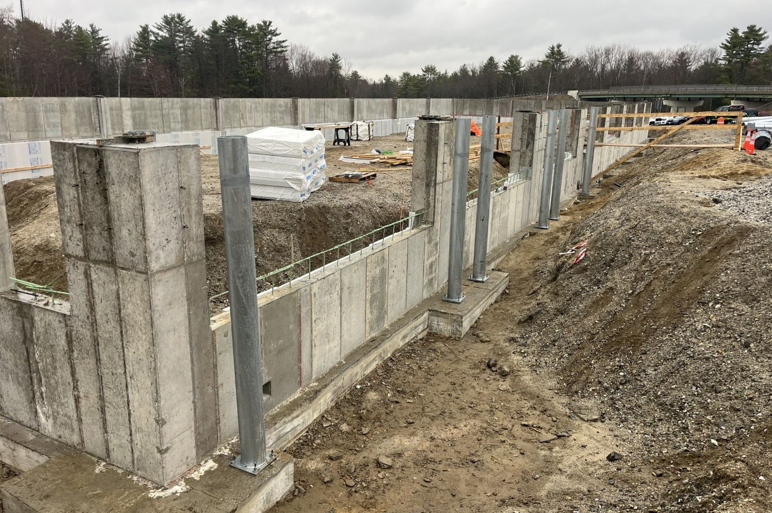
The wall of the new Vehicle Storage Garage is ready for backfill and perimeter drainage.

Contractor: Benchmark Construction Bid Amount: $3,088,432.00

Percent Complete last approved pay estimate: 21.7 %

Project Schedule: Completion date November 20, 2026

Project Scope: Construction of an approximate 8,800 square foot pre-engineered building consisting of eight (8) vehicle storage garage bays. All site work including paving, lighting, generator decommissioning and removal, generator installation, relocating propane tanks, floor slab and foundation removal, power utility services and site utilities. The work also includes all building structure, mechanical, electrical, and plumbing, as well as all other work incidental thereto in accordance with the Plans and Specifications.

Contractor Schedule: The contractor has been working on the building foundation, completing the foundation footing and foundation walls. The contractor is scheduled to backfill the foundation and prepare to begin erecting the pre-engineered metal building mid to late May.

