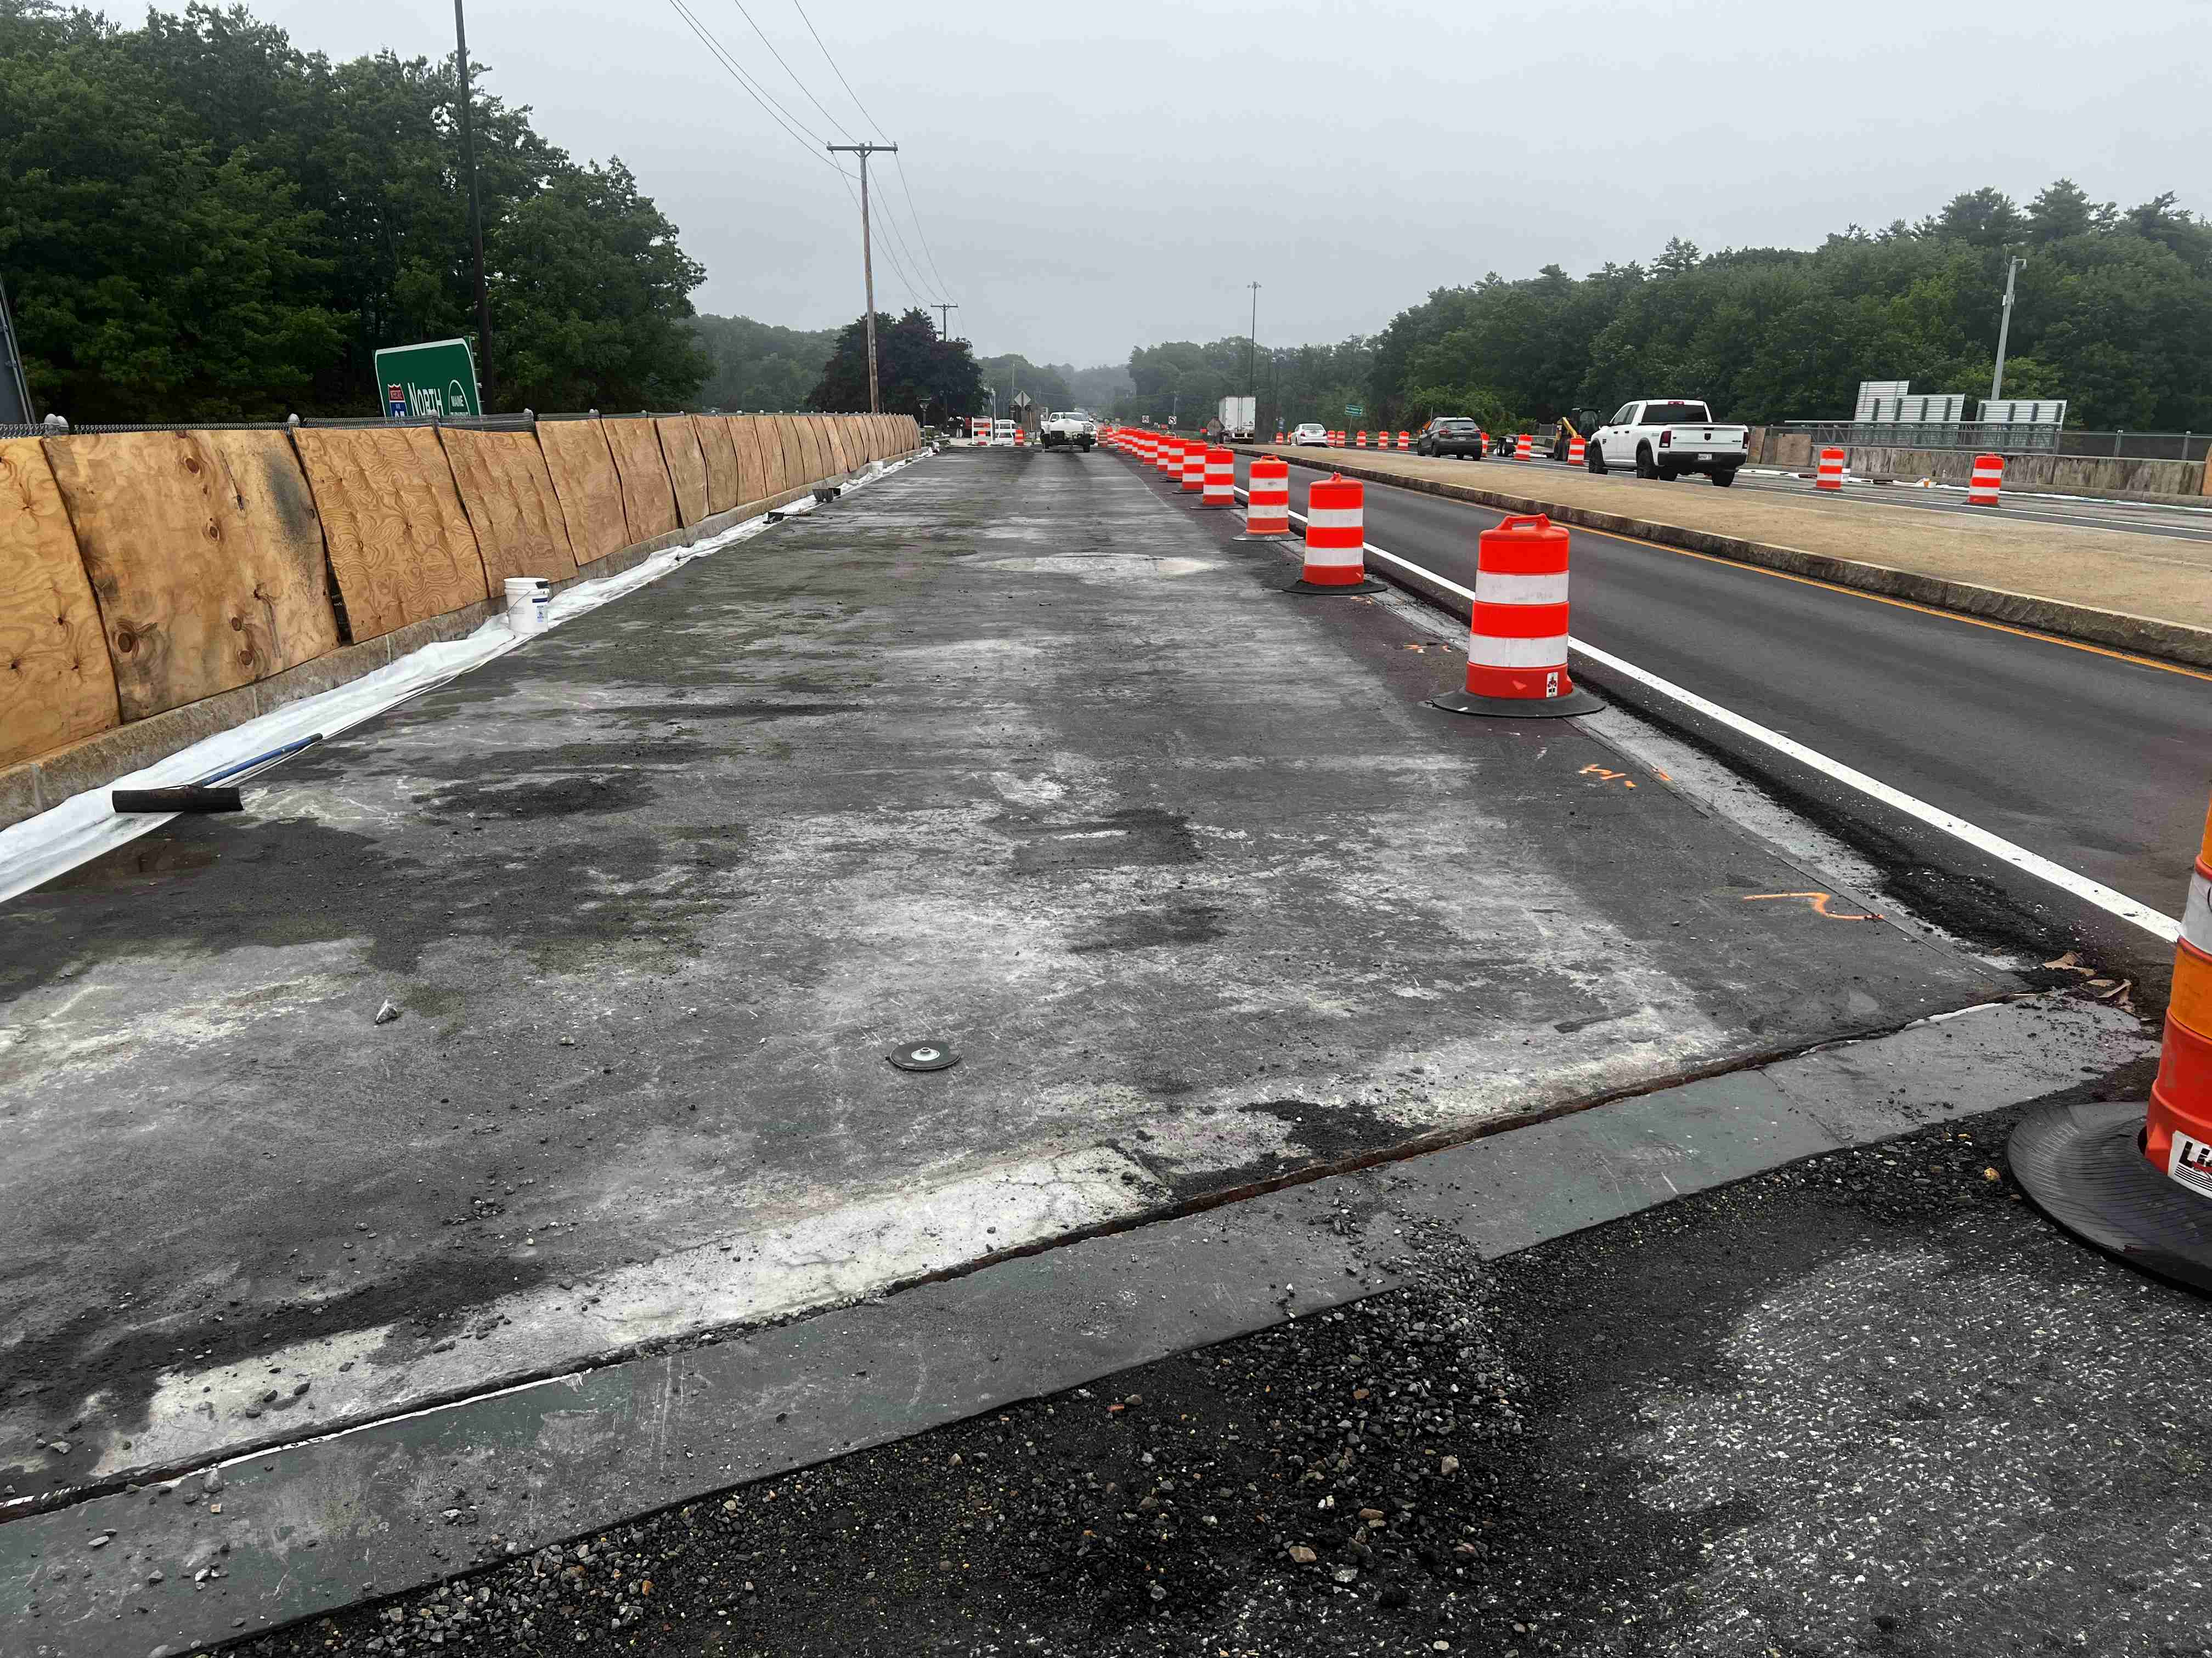

Looking west along the east bound lane of 236. Minor concrete repairs along the gutter line only.

**Contractor:** New England Infrastructure, Inc. **Bid Amount:** $2,579,980.00

**Percent Complete last approved pay estimate:** 59.2%

**Project Schedule:** Completion date November 17, 2023

**Project Scope:** The work consists of bridge repairs at two locations. At the Route 236 Underpass in the Town of Kittery the work generally includes bridge pavement and membrane replacement, approach work and paving, deck expansion joint modifications, median repairs, bearing cleaning and resetting, bridge drain replacement, slope protection repairs, and miscellaneous superstructure and substructure repairs. At the Route 1 On-Ramp (Ramp H) Underpass in the Town of Kittery the work generally includes bridge pavement and membrane replacement, approach work and paving, deck expansion joint modifications, and miscellaneous superstructure and substructure repairs.

**Contractor Schedule:** The contractor has reduced traffic to one lane in each direction on the Route 236 bridge. In this construction phase, the second half of the deck repairs, joint repairs, scupper repairs, placement of new membrane and wearing surface will be completed. The contractor has been making great progress in the second phase of this work and anticipates completing both phases during the spring construction window.