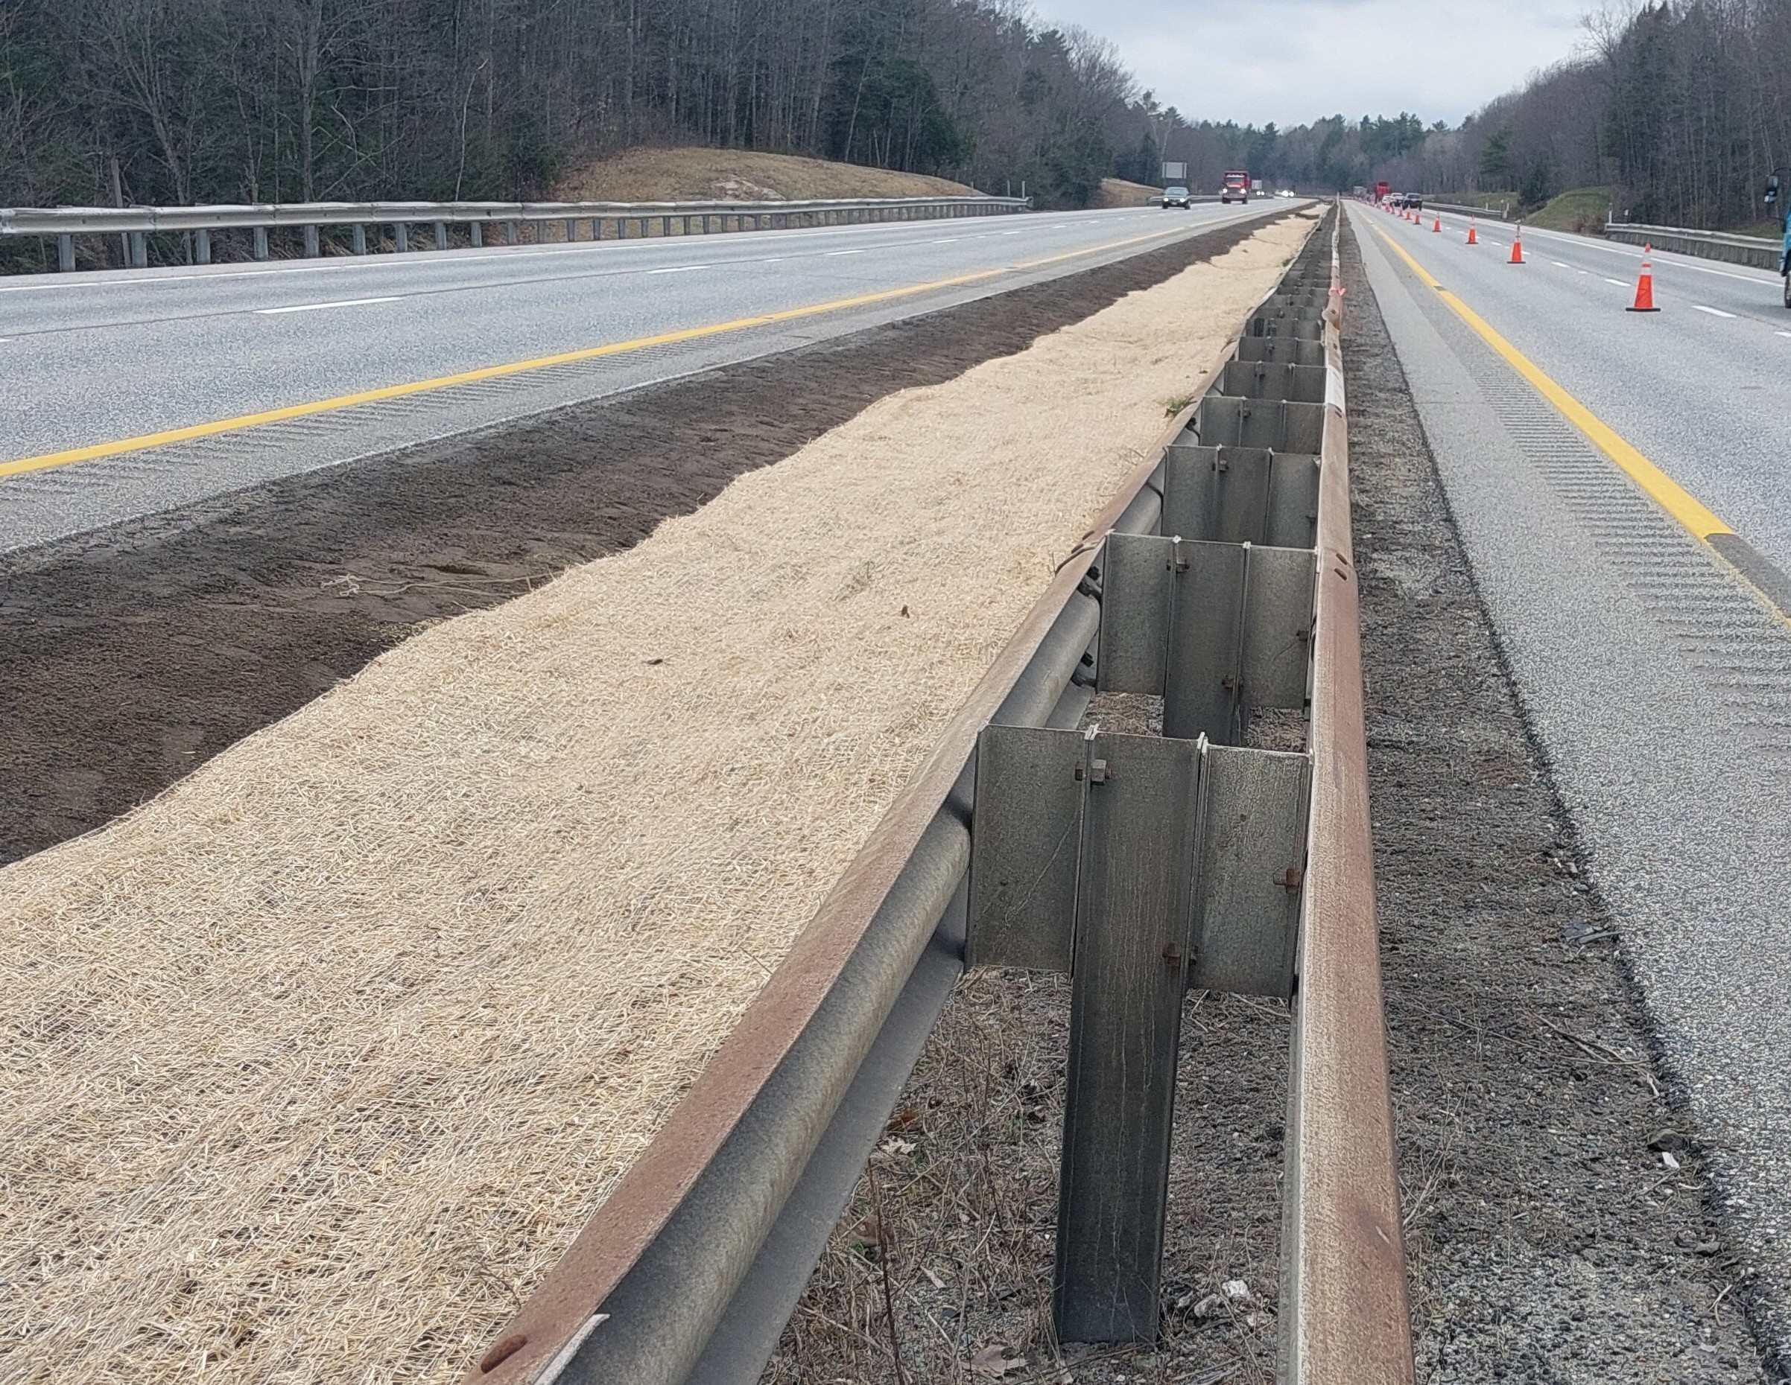
Looking north, Coastal crews have regraded the median to improve drainage.
Contractor: Coastal Road Repair, LLC. Bid Amount: $10,132,469.25

Percent Complete last approved pay estimate: 4.3 %

Project Schedule: Completion date November 14, 2026.

Project Scope: The pavement rehabilitation work consists of milling and filling two travel lanes and the median and outside shoulders for both northbound and southbound approaches. Guardrail height will be adjusted as necessary, with damaged sections of guardrail being replaced where it is needed. Bridge repairs consist of joint modifications and north abutment joint header installation at the two Royal River Bridges (MM 71.1). All four bridges will have milling and filling of in accordance with the Plan and Specifications.

Contractor Schedule: Crews have been working on median restoration and guardrail repairs as shown on the plans. They will continue to work on median and pipe drainage items. Once complete, they’ll transition to milling and paving, potentially in late May. The bridge joint work will happen later in the season.

