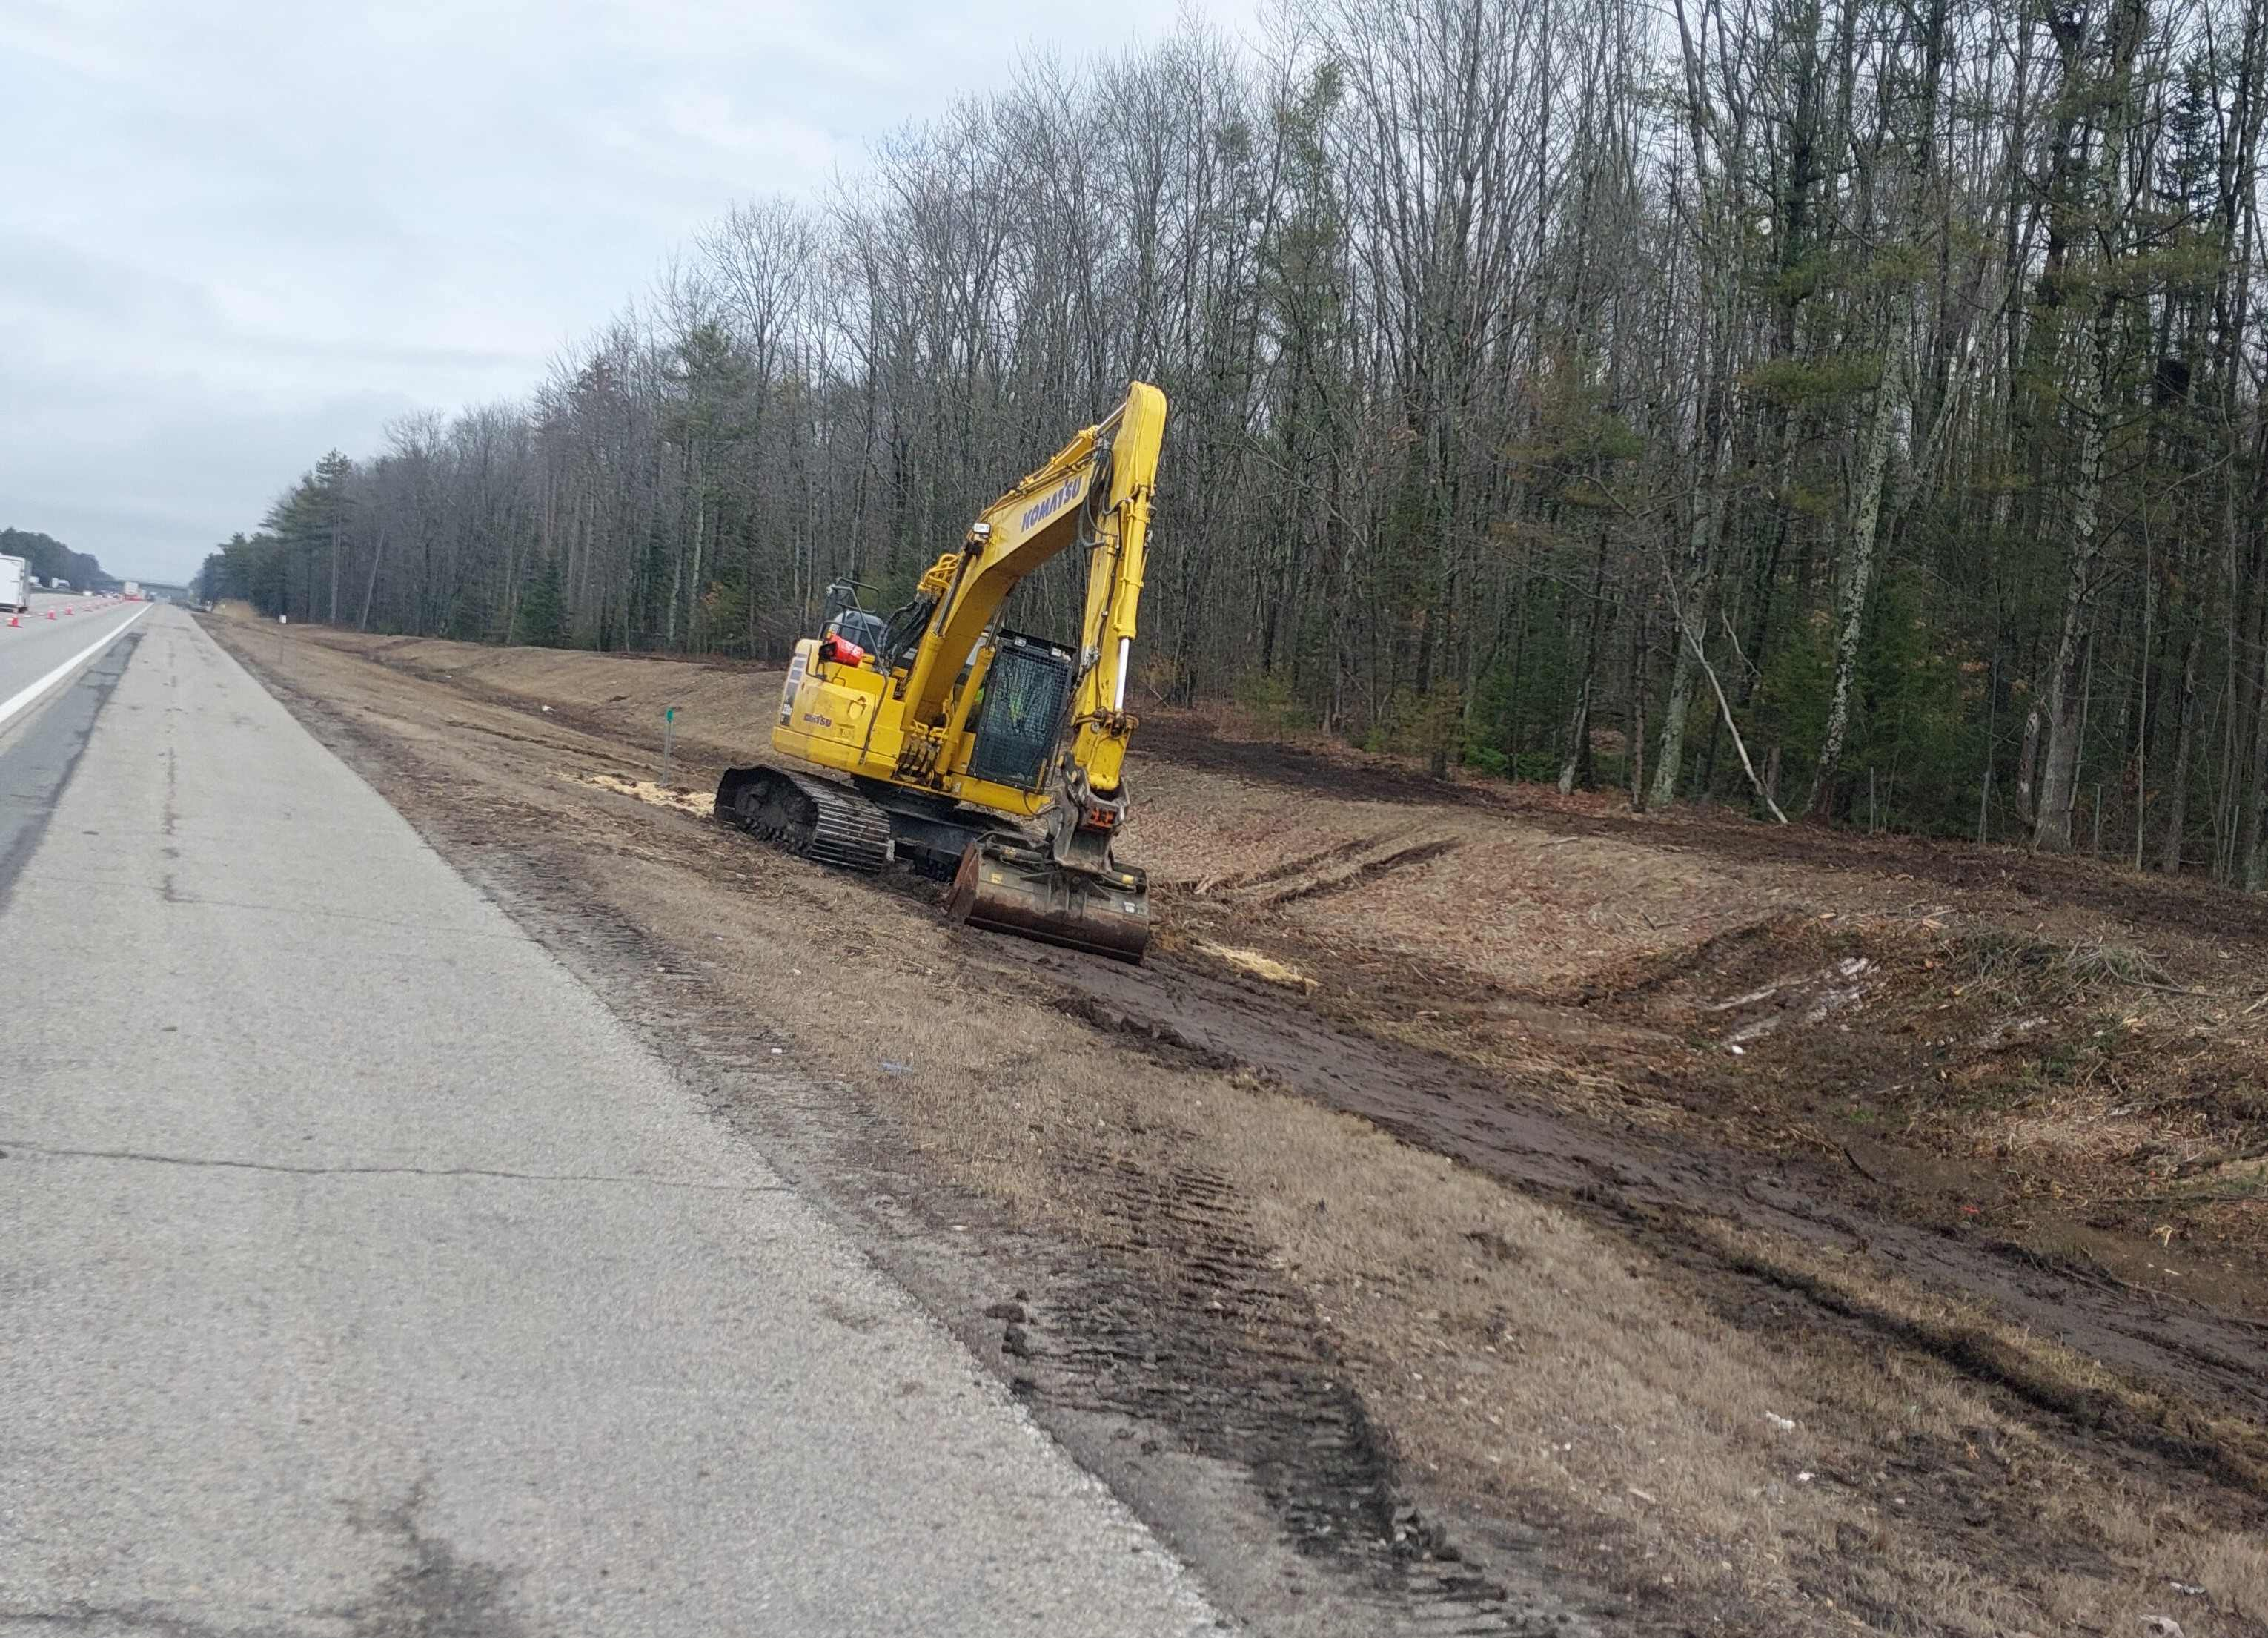

Contractor: Comprehensive Land Technologies, Inc. Bid Amount: $219,196.00

Percent Complete last approved pay estimate: 83.6 %

Project Schedule: Completion date April 17, 2026.

Project Scope: The clearing work consists of clearing trees and other growth, grinding of stumpage, and removal of all forest debris generated during clearing operations or preexisting, and all other work incidental thereto in accordance with the plans and specifications.

Contractor Schedule: Comprehensive Land Technologies, Inc. has finished the clearing contract scope of work with a few remaining punch list items to complete.

