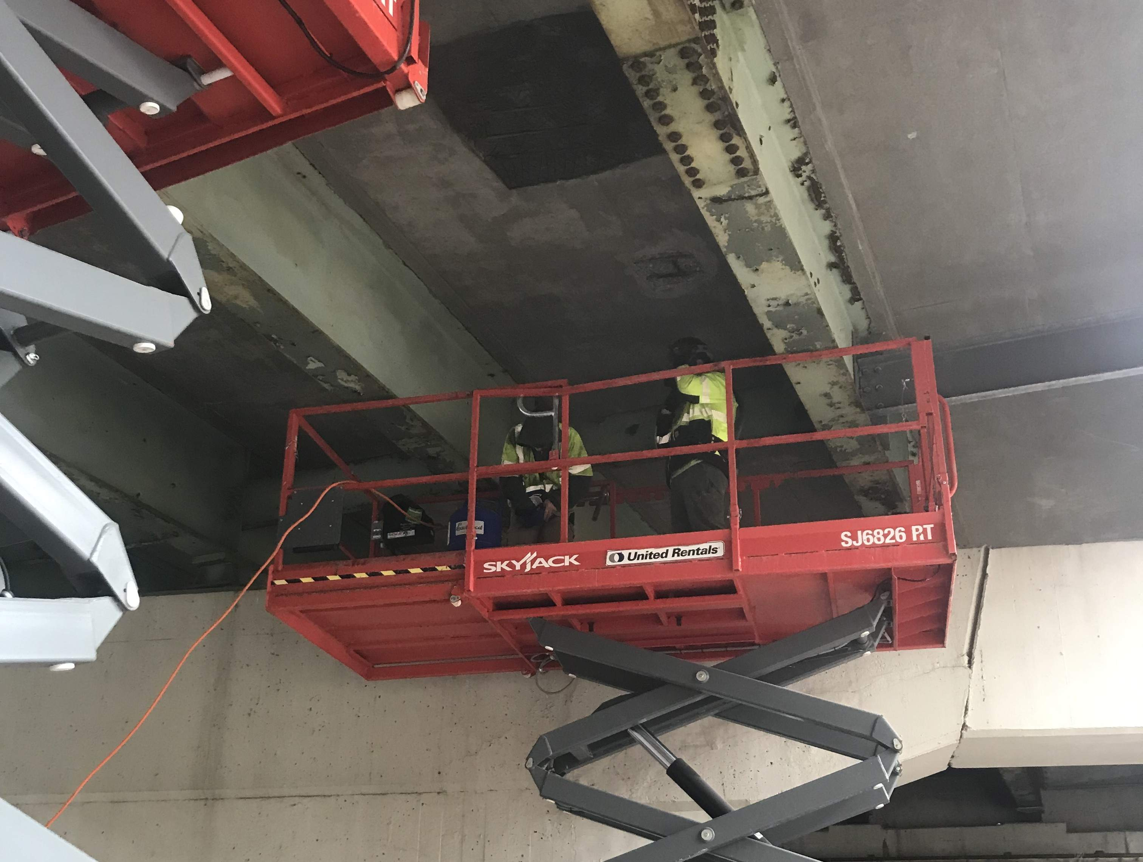
A crew prepares to start an overhead concrete deck repair on the Forest Ave. Bridge.
Contractor: CPM Constructors, Inc. Bid Amount: $1,638,885.84

Percent Complete last approved pay estimate: 59.2 %

Project Schedule: Completion date June 26, 2026.

Project Scope: The work consists of removing and reconstructing the concrete curbs on both sides of the southbound Saco River bridge, installing new railing anchorage and resetting the existing 2-bar aluminum bridge rail. The work at Forest Avenue bridge consists of removing pavement surface, partial depth and full depth deck chipping and patching, deck membrane repair, paving, asphaltic plug joint removal and reinstallation, and maintenance of all required traffic control devices.

Contractor Schedule: CPM has mobilized off the Saco River bridge as they have completed this phase of the work at that location. They are wrapping up the work at Forest Ave as the weather improves. The underside concrete repairs are complete at this time. Crews will be out in early May at night to install the Asphaltic Plug Joint (APJ) on the mainline. They will return in the fall to complete the remaining work at Saco River after Labor Day.

