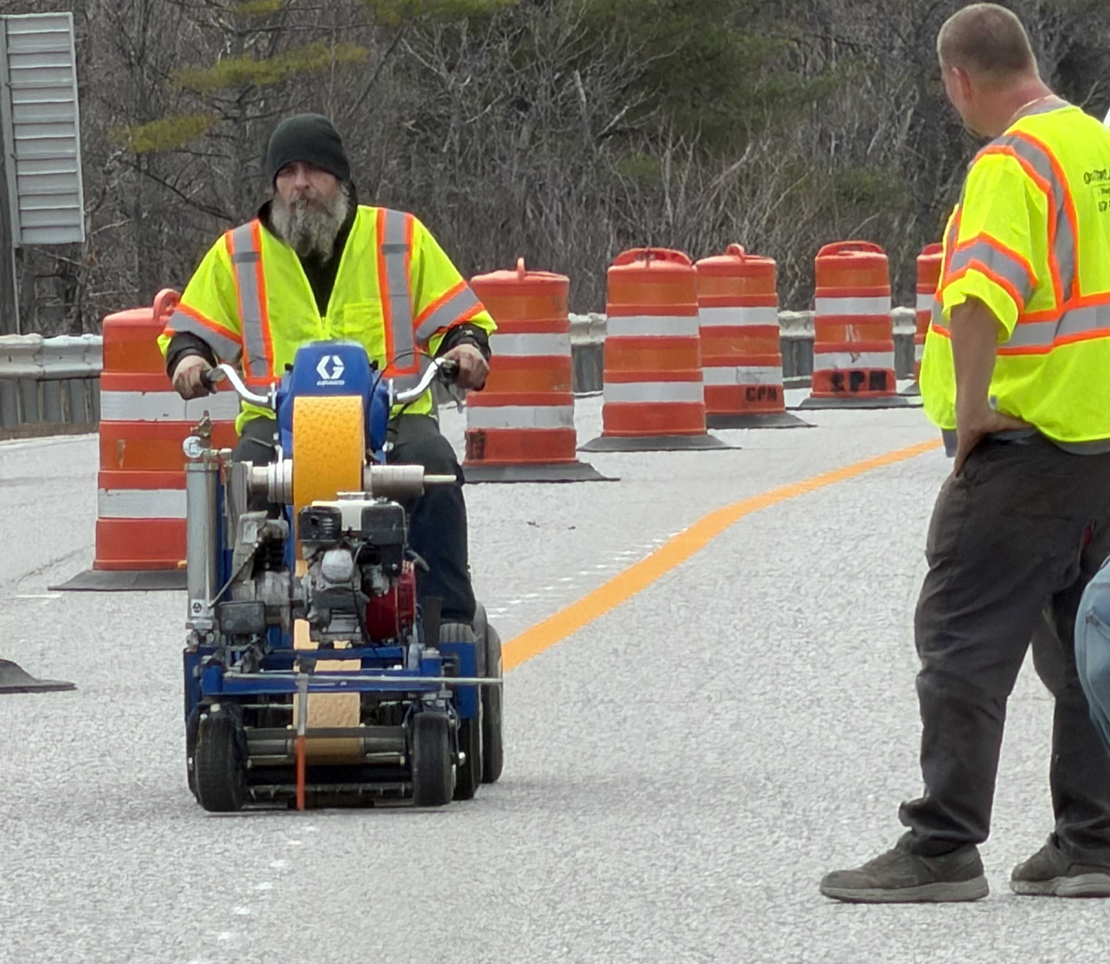
A contractor lays out yellow tape to delineate the new travel lanes as crews gear up for a busy season ahead.
Contractor: CPM Constructors, Inc. Bid Amount: $3,680,501.00

Percent Complete last approved pay estimate: 66.3 %

Project Schedule: Completion date June 18, 2027.

Project Scope: The work consists of repairing the Androscoggin River bridge in the Towns of Auburn and Lewiston, Maine. The work includes bridge joint replacement, parapet and railing repairs, parapet and end post rehabilitation, post-tensioning sleeve repair and replacement, bridge deck milling and paving, median approach construction, guardrail replacement, temporary concrete barrier, and maintenance of traffic.

Contractor Schedule: CPM Constructors has been placing concrete and preparing the project for the next phase of construction. During this phase, the SB bridge will be closed and all lanes will be on the NB bridge. This should take several months for them to complete.

